Predictive Maintenance System for Engine Condition Monitoring 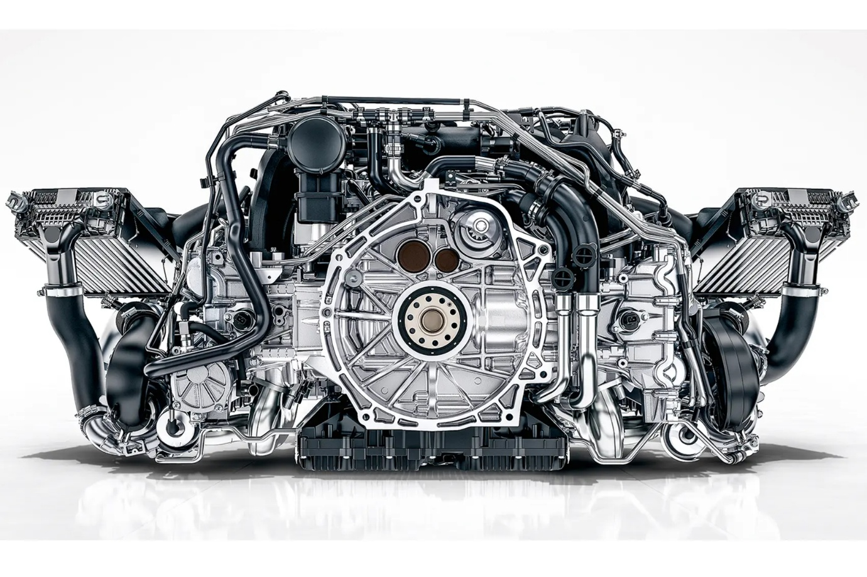
Capstone Project – PGP AIML
Interim Submission Report (31-May-2026)

Prepared & submitted by

Gopikrishna Rajendran
31-May-2026

Table of Contents
Topic | Sub Topic
1. Project Overview | -
2. Business Problem | -
3. Objective | -
4. Data Description: | -
5. Data Registration | 5.1 Folder Structure
 | 5.2 Registering Dataset in Hugging Face Space
6. Exploratory Data Analysis (EDA) | 6.1 Dataset Overview
 | 6.2 Target Variable Distribution
 | 6.3 Feature Distribution
 | 6.4 Correlation Analysis
 | 6.5 Feature vs Target Analysis
 | 6.6 EDA Summary
7. Data Preparation | 7.1 Data Overview
 | 7.2 Data Quality Validation
 | 7.3 Feature Verification
 | 7.4 Outlier Assessment
 | 7.5 Feature Selection
 | 7.6 Train-Test Split
 | 7.7 Data Preparation Summary
8. Model Building | 8.1 Overview
 | 8.2 Logistic Regression
 | 8.3 Decision Tree
 | 8.4 Random Forest
 | 8.5 AdaBoost
 | 8.6 Gradient Boosting
 | 8.7 XGBoost
 | 8.8 Model Building Summary
9. Model Evaluation and Comparison | 9.1 Evaluation Metrics
 | 9.2 Model Performance Comparison
 | 9.3 Comparative Analysis
 | 9.4 Model Selection
 | 9.5 Evaluation Summary
10. Hyperparameter Tuning | 10.1 Overview
 | 10.2 Tuning Methodology
 | 10.3 Parameters Evaluated
 | 10.4 Best Parameters
 | 10.5 Hyperparameter Tuning Results
 | 10.6 Hyperparameter Tuning Summary
11. Conclusion on Best Parameters | -

Topic | Sub Topic
12. Model Deployment | 12.1 Dockerfile Configuration
 | 12.2 Loading the Saved Model from Hugging Face Model Hub
 | 12.3 Getting User Inputs and Converting to DataFrame
 | 12.4 Hosting Deployment Files on Hugging Face Space
13. Automated GitHub Actions Workflow | 13.1 Workflow Overview
 | 13.2 pipeline.yml Structure
 | 13.3 Workflow Execution Steps
 | 13.4 Automated Deployment Flow
14. Output Evaluation | 14.1 GitHub Repository Output
 | 14.2 Streamlit Application Output
 | 14.3 Hugging Face Hosted Application Output
 | 14.4 Hugging Face Model Repository
 | 14.5 Deployment Artifacts and Access Links
15. Actionable Insights and Recommendations | 15.1 Key Business Insights
 | 15.2 Expected Business Benefits
 | 15.3 Expected Business Value
 | 15.4 Future Enhancements
16. Business Report Quality Checklist | -

1. Project Overview

This project focuses on developing a machine learning-based predictive maintenance solution for engine condition monitoring. Using historical engine sensor data, multiple machine learning models were developed and evaluated to predict potential engine failures. The selected model was registered and deployed as a live web application, enabling real-time engine condition assessment and supporting proactive maintenance decisions.

2. Business Problem

Unexpected engine failures can result in costly repairs, operational downtime, reduced productivity, and safety concerns. Traditional maintenance approaches often rely on fixed schedules or reactive actions after a failure occurs, which may lead to unnecessary maintenance costs or unplanned breakdowns. Organizations require a predictive maintenance solution that can leverage engine sensor data to identify potential failures in advance. By analyzing key engine parameters such as RPM, pressure, and temperature, machine learning techniques can help predict engine condition and support proactive maintenance decisions.

3. Objective

The objective of this project is to develop a machine learning-based predictive maintenance system capable of predicting engine failures using operational and sensor data. Multiple machine learning algorithms will be evaluated and compared to identify the most suitable model for failure prediction.
The deployed solution aims to:
- Reduce unexpected engine breakdowns and maintenance costs.
- Improve equipment reliability and operational efficiency.
- Support proactive maintenance planning.
- Enable data-driven decision-making through real-time engine condition assessment.

4. Data Description:

- Engine_RPM: The number of revolutions per minute (RPM) of the engine, indicating engine speed. It is defined in Revolutions per Minute (RPM).
- Lub_Oil_Pressure: The pressure of the lubricating oil in the engine, essential for reducing friction and wear. It is defined in bar or kilopascals (kPa)
- Fuel_Pressure: The pressure at which fuel is supplied to the engine, critical for proper combustion. It is defined in bar or kilopascals (kPa)
- Coolant_Pressure: The pressure of the engine coolant, affecting engine temperature regulation. It is defined in bar or kilopascals (kPa)
- Lub_Oil_Temperature: The temperature of the lubricating oil, which impacts viscosity and engine performance. It is defined in degrees Celsius (°C)
- Coolant_Temperature: The temperature of the engine coolant, crucial for preventing overheating. It is defined in degrees Celsius (°C)
- Engine_Condition: A categorical or numerical label representing the health of the engine, potentially indicating normal operation or various levels of wear and failure risks. It is defined as a categorical variable (0/1) representing a state such as "0 = Off/False/Active" and "1 = On/True/Faulty"

5. Data Registration

5.1 Folder Structure

- The project workspace was organized in PyCharm using a master folder (predictive-maintenance-capstone) with dedicated subfolders for data, notebooks, source code, deployment artifacts, reports, and model files to ensure a structured development workflow

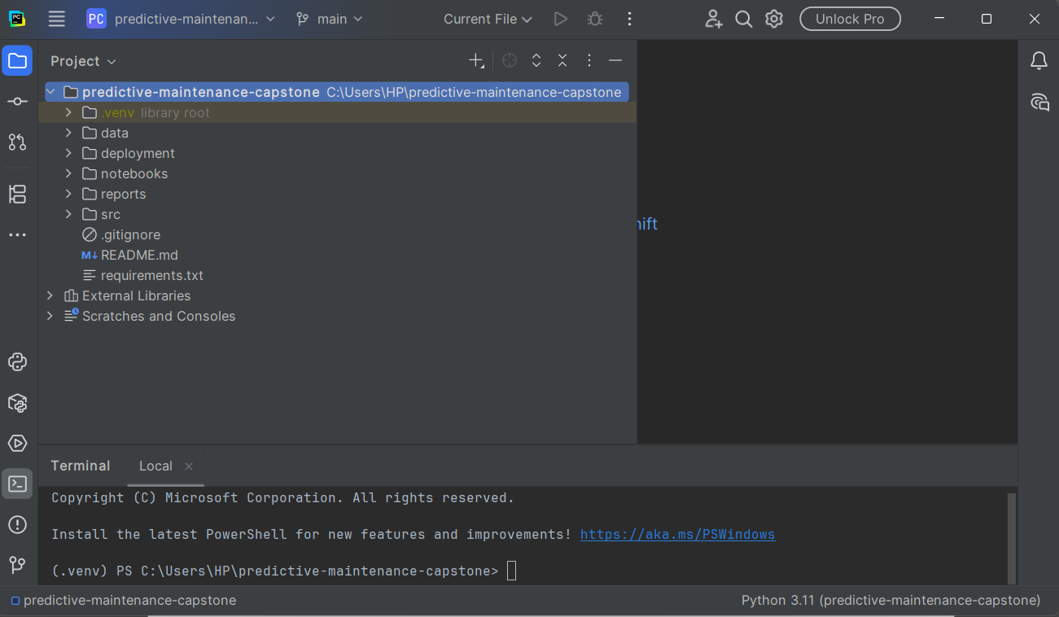

5.2 Registering Dataset in Hugging Face Space

- The dataset was published and versioned in a Hugging Face Dataset Repository to enable centralized access, reproducibility, and future integration with deployment workflows.

- Dataset Repo Link: https://huggingface.co/datasets/gkrishna4346/predictive-maintenance-dataset

Attribute | Value
Dataset Name | engine_data.csv
Records | 19535
Features | 7
Repository Type | Hugging Face Dataset
Access | Private/Public (whichever applies)

Screenshot of Hugging Face Space:

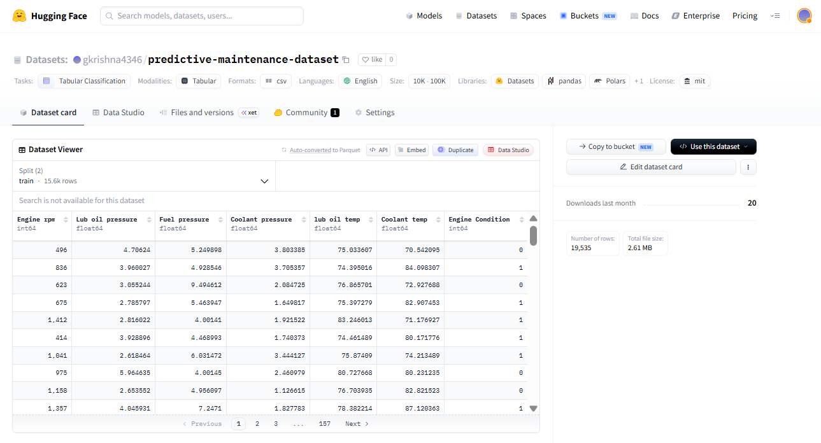

6. Exploratory Data Analysis (EDA)
The exploratory analysis helped identify key patterns in engine operating parameters and their relationship with engine condition. The dataset showed no major data quality issues, and feature analysis revealed meaningful variations between normal and failure cases, supporting the use of machine learning for predictive maintenance.

6.1 Dataset Overview

Metric | Value
Dataset Name | engine_data.csv
Total Records | 19,535
Total Features | 7
Feature Types | All Numerical
Input Features | 6
Target Variable | 1
Missing Values | None (Dataset is complete)
Duplicate Records | None (All records are unique)

- Independent Variables: Engine RPM, Lub Oil Pressure, Fuel Pressure, Coolant Pressure, Lub Oil Temperature, Coolant Temperature & the data type is Numerical (Continuous) for all
- Target Variable: Engine Condition & the data type is Binary (0/1)

6.2 Target Variable Distribution

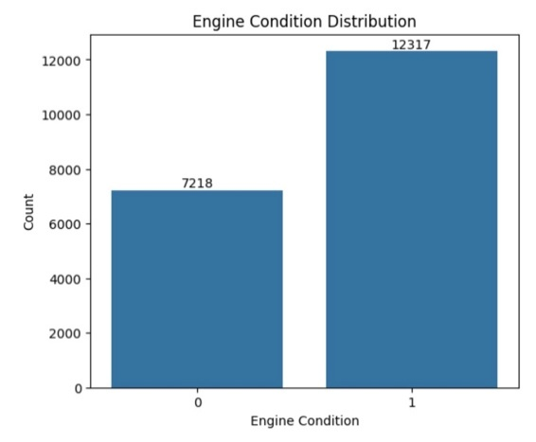 | Key Observations:  - Moderate class imbalance exists (63% vs 37%) — not severe but warrants attention during model evaluation  - Class 0 (Normal Operating Condition) is the minority class with 7,218 records  - Class 1 (Requires Maintenance) is the majority class with 12,317 records
6.3 Feature Distribution

Feature | Distribution Shape | Outlier Presence
Engine RPM | Positively Skewed | Yes — Extreme high values (61–2239 RPM)
Lub Oil Pressure | Positively Skewed | Yes — Upper end outliers
Fuel Pressure | Positively Skewed | Yes — Multiple upper outliers
Coolant Pressure | Positively Skewed | Yes — Occasional high readings
Lub Oil Temperature | Concentrated range | Yes — Clustered between 82–90
Coolant Temperature | Moderate spread | Yes — Few extreme outliers

Key observations:
- All features are continuous and numerical; no categorical encoding required.

6.4 Correlation Analysis
A Pearson correlation analysis was conducted to measure linear relationships between features and the target variable. The analysis indicated low multicollinearity among features, enabling retention of all variables for model development.

Feature | Correlation with  Target Variable | Strength
Engine RPM | -0.27 | Moderate Negative
Fuel Pressure | 0.12 | Weak Positive
Lub Oil Pressure | 0.06 | Negligible
Lub Oil Temperature | -0.09 | Negligible
Coolant Temperature | -0.05 | Negligible
Coolant Pressure | -0.02 | Negligible

Supporting Chart:

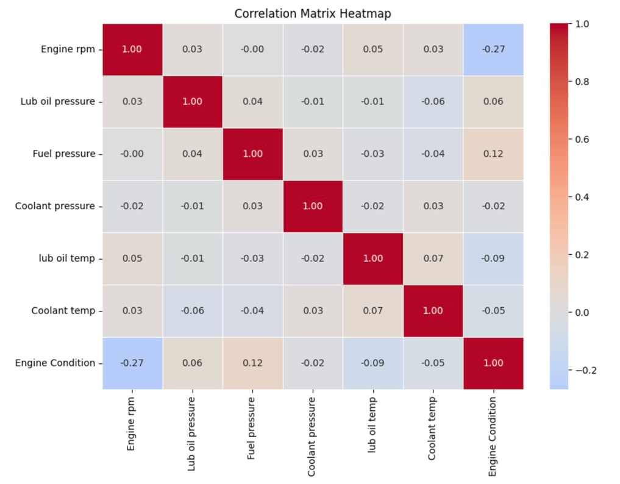
Key Observations:
- Engine RPM is the strongest linear predictor (correlation = -0.27), showing that higher RPM is associated with the maintenance-required condition
- Fuel Pressure has a weak but positive correlation (+0.12) with the normal operating condition
- No pair of features shows high inter-feature correlation, confirming low multicollinearity
- Weak correlations suggest that non-linear models may be more effective in capturing feature-target relationships

6.5 Feature vs Target Analysis
Bivariate analysis (Feature vs Engine Condition) was conducted using boxplots to examine how each feature varies across the two engine condition classes.

Feature | Class 0  (Normal Operating Condition) | Class 1  (Requires Maintenance)
Engine RPM | ≈ 885 | ≈ 736
Fuel Pressure | ≈ 6.24 | ≈ 6.90
Lub Oil Pressure | Lower | Slightly Higher
Coolant Pressure | Similar | Similar
Lub Oil Temperature | Similar | Similar
Coolant Temperature | Similar | Similar

Supporting Chart:
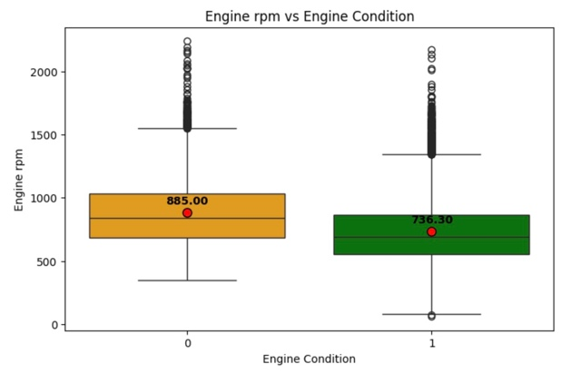 | 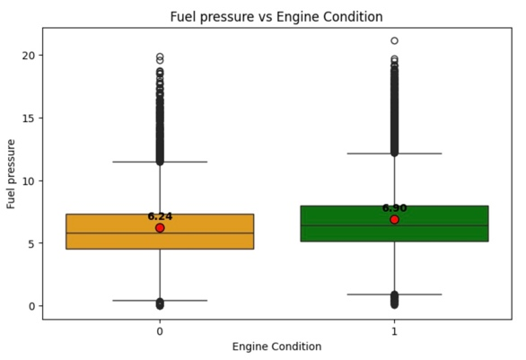
Note: Charts added only for the Comparison of Feature vs Engine Conditions (across classes) which has significant visibility

Key Observations:
- Engine RPM exhibited the most visible separation between classes
- Fuel Pressure showed meaningful variation across engine conditions
- Lub Oil Pressure shows a slight increase in Class 1, though class overlap is substantial.
- Rest all features exhibit nearly identical distributions across both classes.
- Engine failure prediction depends on the combined influence of multiple sensor measurements
- Multivariate Pairplot analysis confirmed that no strong clustering exists — ensemble or non-linear models are preferred

6.6 EDA Summary

Aspect | Finding
Dataset Size | 19,535 records × 7 features (6 predictor variables + 1 target variable)
Data Quality | No missing values or duplicate records; dataset is clean and ready for analysis
Target Variable | Engine Condition (Binary: 0 = Normal Operating Condition, 1 = Maintenance Required)
Class Distribution | Normal Operating Condition: 36.95% (7,218 records) vs Maintenance Required: 63.05% (12,317 records); moderate class imbalance observed
Feature Types | All features are numerical: Engine RPM, Lub Oil Pressure, Fuel Pressure, Coolant Pressure, Lub Oil Temperature, and Coolant Temperature
Key Predictors | Engine RPM showed the strongest relationship with the target variable (corr = -0.27), followed by Fuel Pressure (corr = +0.12)
Multicollinearity | Low multicollinearity observed; no strong inter-feature correlations detected, therefore all features were retained
Outliers | Outliers were identified in multiple features; retained because tree-based models are generally robust to outlier effects
Skewness | Most numerical features exhibited positive skewness, indicating non-normal distributions
ML Readiness | Dataset is suitable for classification tasks. Ensemble techniques such as Random Forest, AdaBoost, and XGBoost are recommended due to their ability to capture complex relationships and improve predictive performance
Next Steps | Develop and evaluate classification models (Decision Tree, Random Forest, AdaBoost, and XGBoost) using Precision, Recall, F1-Score, ROC-AUC, and Confusion Matrix metrics to identify the best-performing predictive maintenance solution

Aspect | Finding
Additional Observation | The dataset contains a higher proportion of maintenance-required instances compared to normal operating conditions. While this distribution may differ from typical real-world operating environments, all analyses and model development activities were performed using the class definitions and distribution provided in the dataset

7. Data Preparation
7.1 Data Overview
Data preparation was performed to ensure that the dataset was suitable for machine learning model development. The process included data quality checks, validation of feature types, assessment of missing values and duplicates, outlier analysis, feature selection, and train-test splitting.

7.2 Data Quality Validation

The dataset was examined to identify potential data quality issues that could impact model performance.

Activities Performed:
- Verified dataset dimensions and structure
- Reviewed feature data types
- Checked for missing values
- Checked for duplicate records
- Validated target variable consistency

Preliminary Findings:

Validation Check | Result
Missing Values | None
Duplicate Records | None
Invalid Data Types | None
Target Variable Issues | None

7.3 Feature Verification

- All six predictor variables were numerical and represented engine operating parameters.
- No feature encoding was required because all predictor variables were already numerical.
7.4 Outlier Assessment
Boxplot analysis performed during exploratory data analysis identified the presence of outliers in multiple numerical features.

Findings:
- Engine RPM contained several high-value observations.
- Fuel Pressure and Lub Oil Pressure showed upper-end outliers.
- Temperature-related features contained a few extreme values.

Note:
Since the selected machine learning algorithms include Decision Tree, Random Forest, AdaBoost, and XGBoost, which are generally robust to outliers, no outlier treatment was applied. All records were retained to preserve operational variability.
7.5 Feature Selection
Correlation analysis and exploratory data analysis were used to evaluate feature relevance.
Findings:
- Engine RPM showed the strongest relationship with the target variable.
- Fuel Pressure exhibited a weak positive relationship with engine condition.
- No strong multicollinearity was observed among features.

Therefore, all six predictor variables were retained for model development.
7.6 Train-Test Split
To evaluate model performance on unseen data, the dataset was divided into training and testing subsets.

Parameter | Value
Training Data | 80%
Testing Data | 20%
Random State | 42

The training dataset was used to build machine learning models, while the testing dataset was reserved for model evaluation.

7.7 Data Preparation Summary
Step | Outcome
Missing Value Check | No missing values identified
Duplicate Check | No duplicate records found
Feature Verification | All variables numerical
Outlier Assessment | Outliers retained
Feature Selection | All six predictors retained
Train-Test Split | 80:20
Dataset Readiness | Suitable for model development

The dataset required minimal pre-processing due to its high quality and complete structure. Following validation and preparation activities, the dataset was considered ready for machine learning model development and evaluation.

8. Model Building
8.1 Overview
Multiple machine learning classification algorithms were developed and trained to predict engine condition based on operational sensor measurements. Both single-tree and ensemble learning techniques were evaluated to identify the most effective predictive maintenance solution.

The selected models include:
- Logistic Regression
- Decision Tree
- Random Forest
- AdaBoost
- Gradient Boosting
- XGBoost

These algorithms were chosen because they can effectively handle numerical data, capture non-linear relationships, and provide strong classification performance.

8.2 Logistic Regression

Model Rationale: Logistic Regression was selected as the baseline statistical classification model due to its simplicity, interpretability, and effectiveness in binary classification problems.

Key Characteristics:
- Suitable for binary classification
- Provides interpretable predictions
- Establishes a benchmark for evaluating advanced models.

8.3 Decision Tree

Model Rationale: A Decision Tree classifier was developed to capture non-linear relationships between engine operating parameters and engine condition.

Key Characteristics:
- Easy to interpret
- Handles numerical features without scaling
- Serves as a baseline tree-based model
8.4 Random Forest

Model Rationale: Random Forest was developed to improve predictive performance by combining multiple decision trees using a bagging approach.

Key Characteristics:
- Reduces overfitting
- Improves prediction stability
- Captures complex feature interactions

8.5 AdaBoost

Model Rationale: AdaBoost was developed as a boosting-based ensemble model that focuses on correcting previously misclassified observations.

Key Characteristics:
- Sequential learning approach
- Improves classification performance
- Effective for structured tabular datasets
8.6 Gradient Boosting

Model Rationale: Gradient Boosting was developed to build a strong predictive model by sequentially minimizing prediction errors.

Key Characteristics:
- Learns from residual errors
- Captures non-linear relationships
- Generally provides strong classification performance

8.7 XGBoost

Model Rationale: XGBoost was developed as an advanced gradient boosting framework designed for efficiency, scalability, and predictive accuracy.

Key Characteristics:
- Regularization reduces overfitting
- Handles complex feature interactions
- Widely used in machine learning competitions and industry applications

8.8 Model Building Summary

Model | Category | Type | Key Observation
Logistic Regression | Linear Model | Baseline | The selected models progress from linear classification to advanced ensemble methods, enabling fair comparison and identification of the most effective predictive maintenance solution.
Decision Tree | Tree-Based | Baseline Tree Model
Random Forest | Ensemble | Bagging
AdaBoost | Ensemble | Boosting
Gradient Boosting | Ensemble | Boosting
XGBoost | Ensemble | Advanced Boosting

9. Model Evaluation and Comparison
9.1 Evaluation Metrics
To evaluate model performance, multiple classification metrics were considered. Since the dataset exhibits moderate class imbalance, relying solely on accuracy may not provide a complete assessment of model effectiveness.
The following metrics were used:
Metric | Description
Accuracy | Overall proportion of correctly classified observations
Precision | Ability to correctly identify maintenance-required engines
Recall | Ability to detect actual maintenance-required engines
F1-Score | Harmonic mean of Precision and Recall
ROC-AUC | Ability to distinguish between the two classes across different thresholds

Metrics such as Precision, Recall, F1-Score, and ROC-AUC were given greater importance than accuracy because they provide a more comprehensive assessment of classification performance under class imbalance conditions.

9.2 Model Performance Comparison

Model | Accuracy | ROC-AUC | Precision | Recall | F1-Score
Logistic Regression | 0.6560 | 0.6804 | 0.6737 | 0.8810 | 0.7635
Decision Tree | 0.5930 | 0.5610 | 0.6750 | 0.6837 | 0.6793
Random Forest | 0.6453 | 0.6773 | 0.6887 | 0.7978 | 0.7393
AdaBoost | 0.6688 | 0.7050 | 0.6979 | 0.8368 | 0.7611
Gradient Boosting | 0.6647 | 0.7035 | 0.6920 | 0.8437 | 0.7603
XGBoost | 0.6455 | 0.6700 | 0.6925 | 0.7873 | 0.7368

9.3 Comparative Analysis

9.3.1 Logistic Regression
- Achieved the highest Recall (88.10%).
- Achieved the highest F1-Score (76.35%).
- Demonstrated strong ability to identify maintenance-required engines.
- Performance suggests that the relationship between features and target variables can be partially captured using a linear decision boundary.

9.3.2 Decision Tree
- Produced the lowest Accuracy and ROC-AUC among all models.
- More susceptible to overfitting compared to ensemble methods.
- Served as a useful baseline tree-based model.

9.3.3 Random Forest
- Improved performance over Decision Tree.
- Demonstrated better stability through ensemble learning.
- Produced balanced classification performance across evaluation metrics.

9.3.4 AdaBoost
- Achieved the highest Accuracy (66.88%).
- Achieved the highest ROC-AUC (70.50%).
- Achieved the highest Precision (69.79%).
- Demonstrated strong overall performance across all evaluation metrics.

9.3.5 Gradient Boosting
- Delivered performance very close to AdaBoost.
- Achieved strong Recall and ROC-AUC values.
- Demonstrated effective learning of complex relationships in the dataset.

9.3.6 XGBoost
- Produced competitive results but did not outperform AdaBoost or Gradient Boosting.
- Demonstrated reasonable classification capability and model stability.

9.4 Model Selection

Although Logistic Regression achieved the highest Recall and F1-Score, AdaBoost was selected as the final model because it provided the best overall balance across evaluation metrics.

Reasons for Selecting AdaBoost:

Criterion | Observation
Accuracy | Highest among all models
ROC-AUC | Highest among all models
Precision | Highest among all models
Recall | Strong performance
Model Stability | Consistent across metrics
Interpretability | Easier deployment compared to more complex boosting frameworks

AdaBoost demonstrated superior discriminative capability while maintaining a balanced trade-off between false positives and false negatives, making it the most suitable model for the predictive maintenance use case.

9.5 Evaluation Summary

The comparative analysis showed that ensemble learning techniques consistently outperformed the standalone Decision Tree model. Among the evaluated algorithms, AdaBoost achieved the strongest overall performance, delivering the highest Accuracy, ROC-AUC, and Precision while maintaining competitive Recall and F1-Score values. Based on these results, AdaBoost was selected as the final model for subsequent deployment and predictive maintenance analysis.
10. Hyperparameter Tuning
10.1 Overview

After evaluating multiple machine learning algorithms, AdaBoost emerged as the best-performing model based on Accuracy, Precision, and ROC-AUC. To further optimize its predictive performance, hyperparameter tuning was performed using Grid Search Cross Validation (GridSearchCV).

The objective was to identify the optimal combination of model parameters that maximized classification performance while maintaining generalization capability.

10.2 Tuning Methodology

GridSearchCV was employed to systematically evaluate multiple parameter combinations for the AdaBoost classifier.

Benefits of Grid Search
- Automated parameter optimization
- Systematic evaluation of parameter combinations
- Cross-validation-based performance assessment
- Improved model reliability and generalization

The ROC-AUC score was selected as the optimization metric because it provides a robust measure of the model's ability to distinguish between maintenance-required and normal operating conditions.

10.3 Parameters Evaluated

The following AdaBoost hyperparameters were explored:

Parameter | Description
n_estimators | Number of weak learners used during boosting
learning_rate | Controls the contribution of each weak learner

Candidate Values:
Parameter | Values Evaluated
n_estimators | 50, 100, 150, 200
learning_rate | 0.01, 0.1, 0.5, 1.0

10.4 Best Parameters

The Grid Search process identified the following optimal parameter combination:

Parameter | Best Value
learning_rate | 0.1
n_estimators | 200

Best Cross-Validation Performance:
Metric | Value
ROC-AUC Score | 0.7012

10.5 Hyperparameter Tuning Results

The tuning process successfully identified an improved AdaBoost configuration that achieved strong classification performance across validation folds.

Key Observations:
- Increasing the number of estimators improved the model's learning capability.
- A moderate learning rate of 0.1 provided a good balance between learning speed and model stability.
- The tuned AdaBoost model achieved a cross-validated ROC-AUC score of 0.7012.
- The optimized model demonstrated strong capability in distinguishing maintenance-required engines from normal operating engines.

10.6 Hyperparameter Tuning Summary

Activity | Outcome
Model Tuned | AdaBoost
Optimization Technique | GridSearchCV
Validation Method | Cross Validation
Best Learning Rate | 0.1
Best Number of Estimators | 200
Best ROC-AUC Score | 0.7012
Final Model Status | Selected for Deployment

11. Conclusion:

Hyperparameter tuning enhanced the AdaBoost model by identifying the optimal parameter configuration of learning_rate = 0.1 and n_estimators = 200. The tuned model achieved a ROC-AUC score of 0.7012 and was selected as the final predictive maintenance model for deployment.

Figure 10.1: Optimal AdaBoost Hyperparameters Identified using GridSearchCV

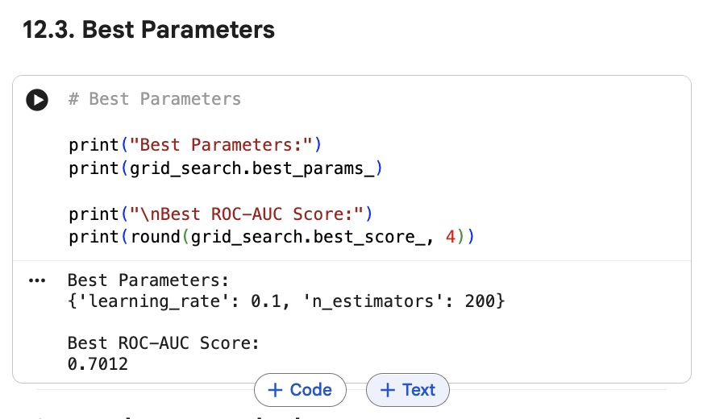

12. Model Deployment

After selecting the final optimized AdaBoost model through hyperparameter tuning, the model was deployed to provide real-time predictive maintenance predictions through a web application hosted on Hugging Face Spaces.

12.1 Dockerfile Configuration

To support reproducible deployment and execution, a Docker-based deployment environment was configured.

The Docker configuration was responsible for:
- Creating a standardized runtime environment
- Installing all required dependencies
- Defining the application execution process
- Packaging deployment files for hosting

Docker Configuration Components
- Base Python environment
- Application working directory
- Dependency installation using requirements.txt
- Streamlit execution configuration
- Port exposure for application hosting

Deployment Folder Structure

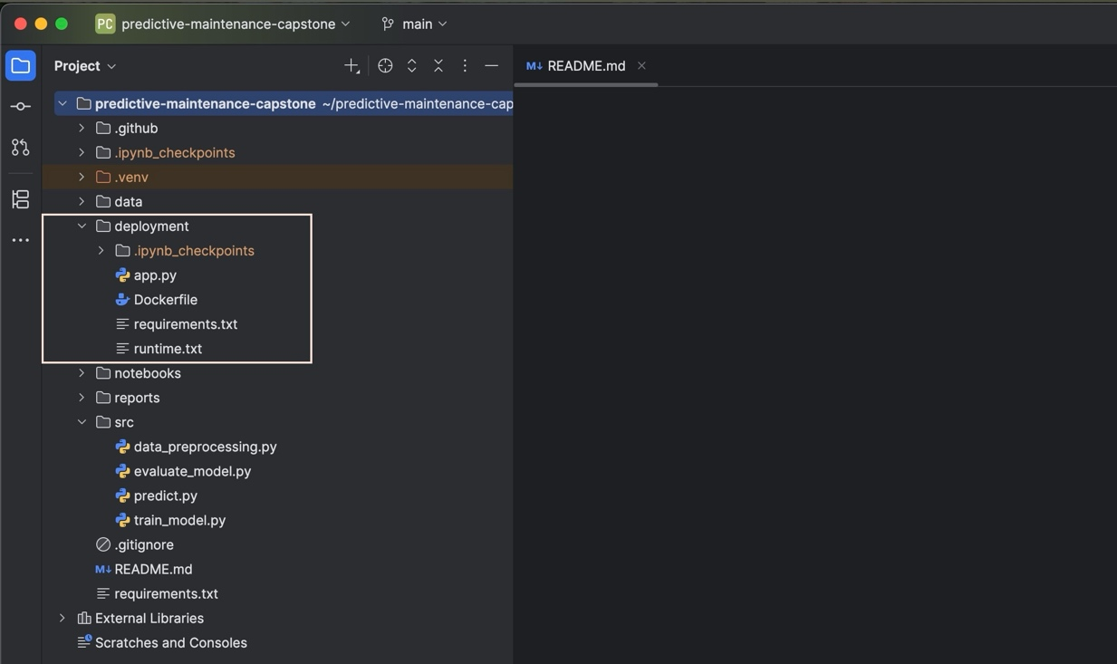

Deployment File Description

File Name | Description
app.py | Collects inputs, loads the model, and generates predictions
Dockerfile | Configures the deployment environment and execution
requirements.txt | Defines all deployment dependencies
runtime.txt | Specifies the Python runtime version (python-3.11)
12.2 Loading the Saved Model from Hugging Face Model Hub

The trained predictive maintenance model was uploaded and stored in the Hugging Face Model Hub for deployment.

During application execution:
- Connect to Hugging Face Model Hub
- Download the saved model artifact
- Load the model into memory
- Perform real-time prediction

Model loading flow:
Hugging Face
Model Hub
Download Model
Load Saved Model
Perform Prediction

This approach enables centralized model storage and eliminates the need for retraining during deployment.

Hugging Face Model Hub

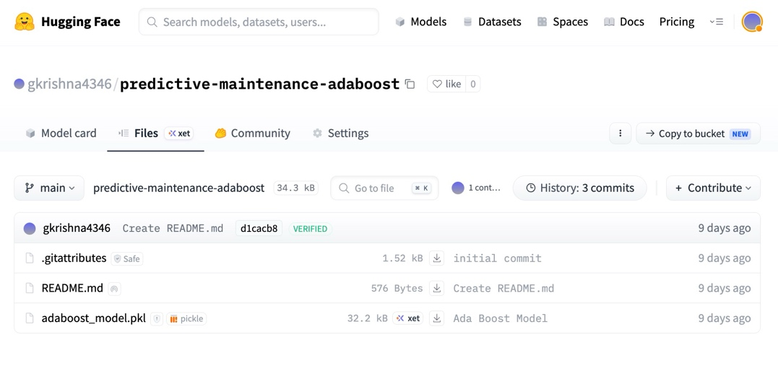

Code Snippet for Downloading Model from Hugging Face

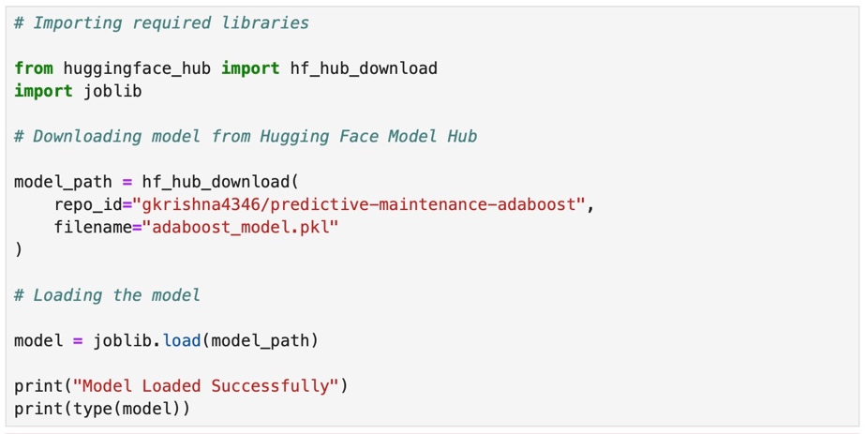

The deployed application retrieves the serialized AdaBoost model from Hugging Face Model Hub and loads it into memory for real-time inference.

12.3 Getting User Inputs and Converting to DataFrame

The deployed Streamlit application collects engine operating parameters through user input controls. The captured values are converted into a Pandas DataFrame and passed to the deployed model for prediction.

Input parameters collected:
- Engine RPM
- Lub Oil Pressure
- Fuel Pressure
- Coolant Pressure
- Lub Oil Temperature
- Coolant Temperature

Input Processing Flow
User Inputs
Store Values
Create DataFrame
Send to Model
Perform Prediction

Code Snippet for Creating Input DataFrame

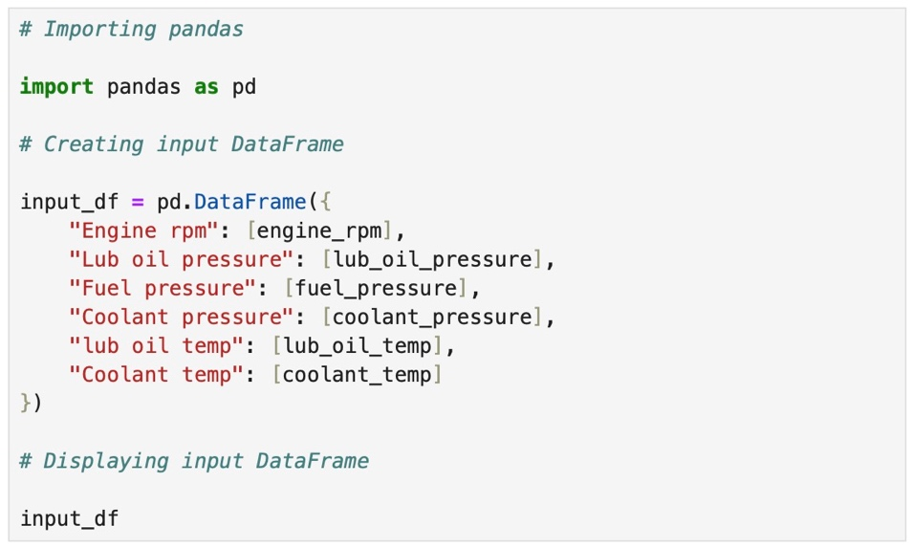

12.4 Hosting Deployment Files on Hugging Face Space

To deploy the predictive maintenance application, deployment files were pushed from the local Git repository into the Hugging Face Space repository. The hosting workflow enables automatic rebuilding and publishing of the application whenever deployment files are updated.

12.4.1 Hosting Workflow

Deployment Workflow
Local Project
Git Commit
Push to GitHub
Deploy to Hugging Face Space
Automatic Build & Hosting

12.4.1 Deployment Commands

Deployment Commands | Description
git add . | To add updated deployment files
git commit -m "Deployment update" | To create deployment commit
git push origin main | To push changes to GitHub
git push hf main --force | To push deployment files to Hugging Face Space

Post deployment, Hugging Face Space automatically:

- Builds the application environment
- Installs dependencies
- Loads the hosted model
- Publishes the Streamlit application
Deployment Outcome

The deployed application became accessible through a public Hugging Face Space URL for real-time prediction.

13. Automated GitHub Actions Workflow

GitHub Actions was implemented to automate the machine learning deployment workflow. A workflow configuration file (pipeline.yml) was created to define the execution sequence and enable automated processing whenever updates are pushed to the repository.

The automated workflow reduces manual intervention, improves deployment consistency, and supports reproducible application updates.

13.1 Workflow Overview
The GitHub Actions workflow automates deployment activities through a predefined YAML configuration. Whenever code changes are pushed to the main branch, the workflow is triggered automatically and executes the deployment sequence.

Workflow objective:
- Monitor updates in the repository
- Execute predefined deployment steps
- Push updated deployment files
- Maintain synchronization between source code and hosted application
Code Update
Push to GitHub
Trigger pipeline.yml
Execute Workflow
Update Deployment
Publish Application

13.2 pipeline.yml Structure
A. Create pipeline.yml file in GitHub repo

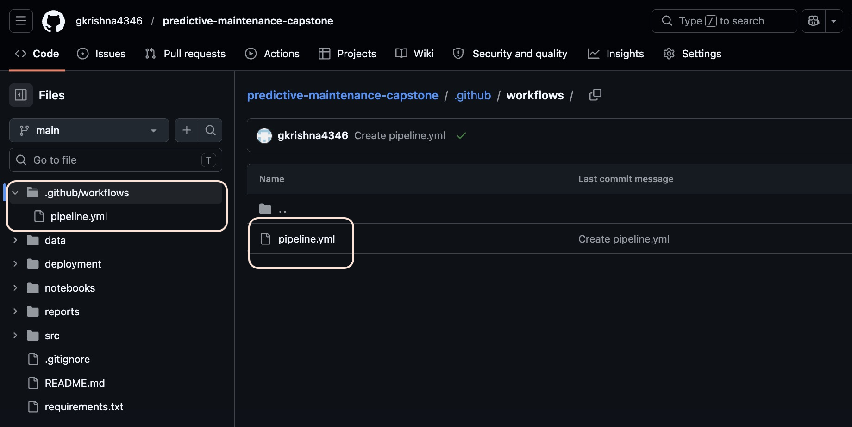

B. Define YAML file and list all steps

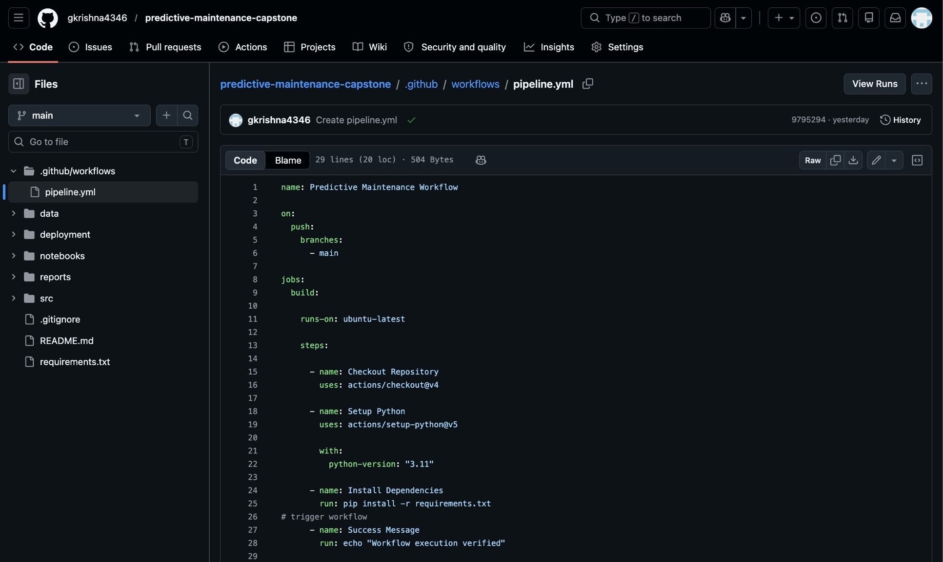

Key Workflow Configuration

Section | Purpose
name | Defines workflow name
on | Defines trigger event
jobs | Groups execution tasks
steps | Executes workflow commands

13.3 Workflow Execution Steps
Step | Description
Repository Checkout | Retrieves latest source code
Environment Setup | Configures runtime
Dependency Installation | Installs required libraries
Model Loading | Accesses hosted model
Deployment Execution | Publishes updated application

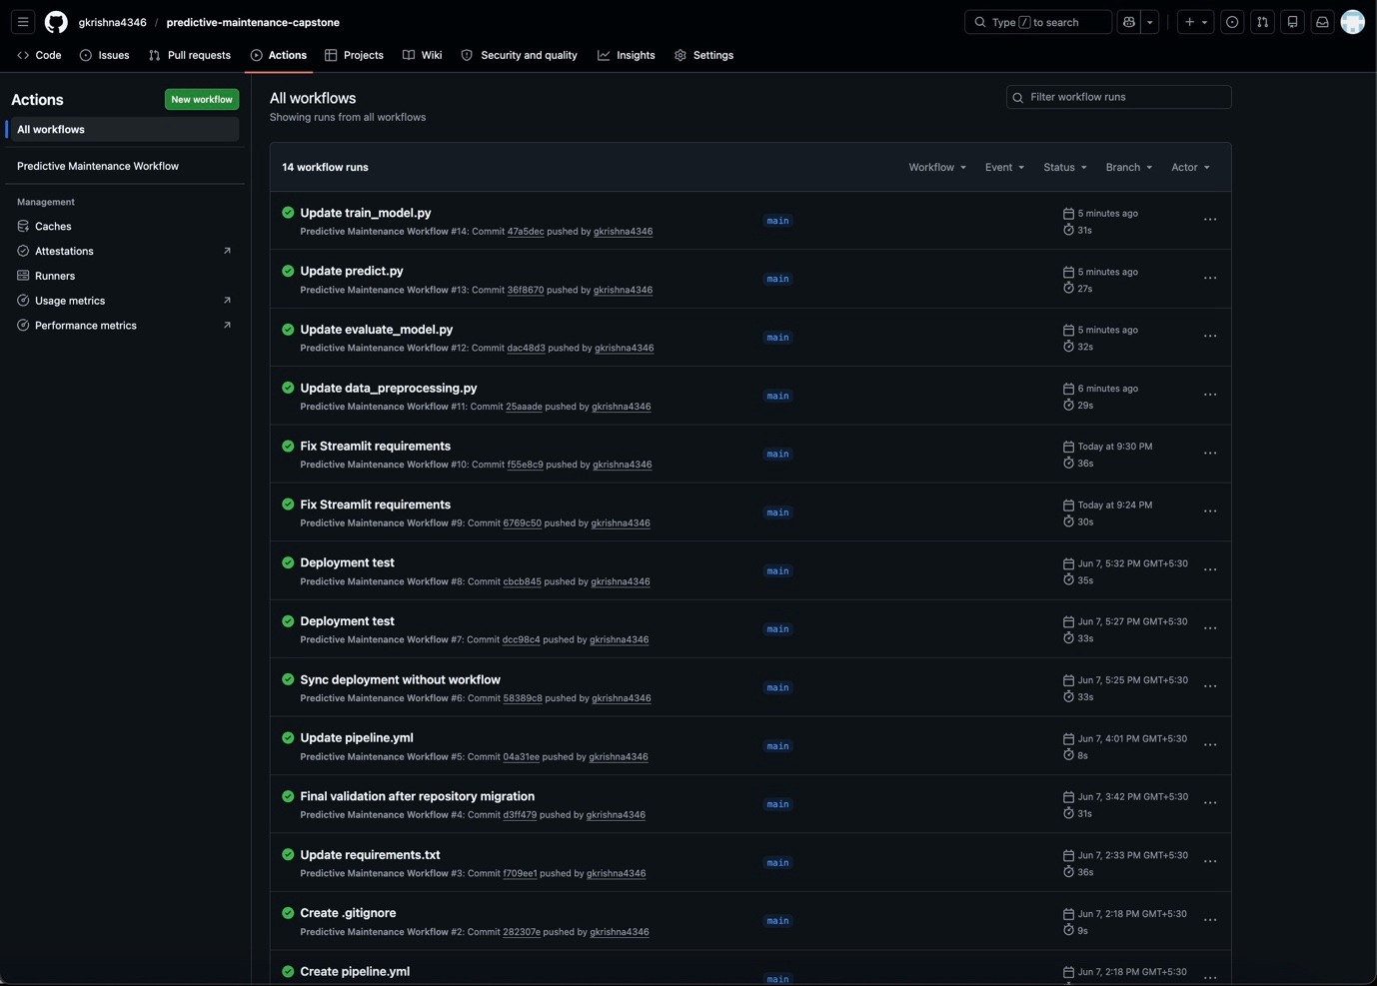

13.4 Automated Deployment Flow
Local Update
Git Commit
Push to GitHub
GitHub Actions Trigger
Execute Pipeline
Deploy Application
Hosted Output Updated

14. Output Evaluation

The automated workflow reduced manual deployment effort and ensured that application updates could be propagated through a structured and repeatable execution process. This approach improved deployment consistency and simplified maintenance activities.

14. Output Evaluation

This section presents the final outputs generated during implementation and deployment. Repository artifacts, workflow execution, and hosted application outputs are included to validate successful execution of the end-to-end solution.

14.1 GitHub Repository Output

A. Repository screenshot

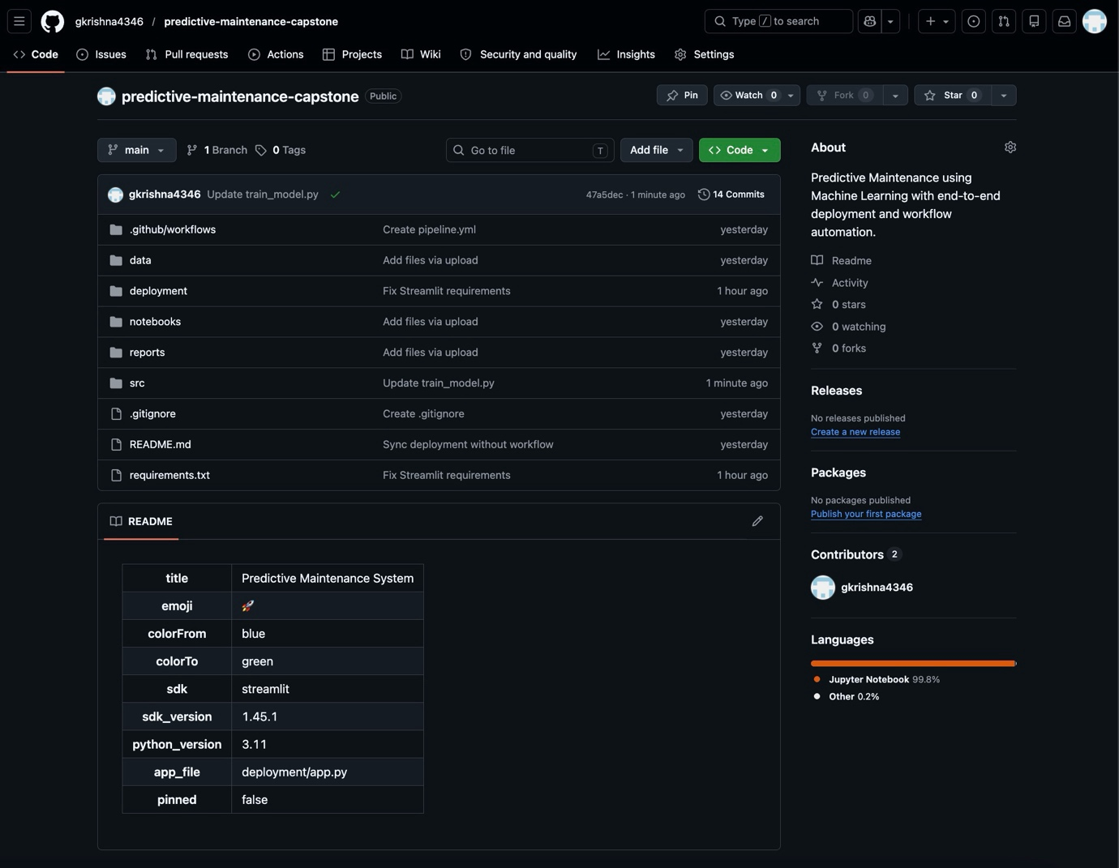

B. Folder structure

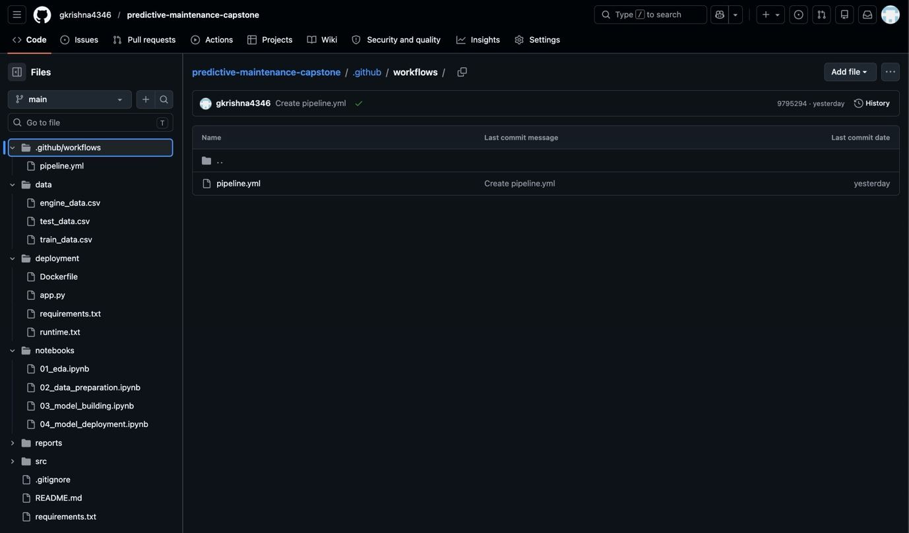

C. Workflow execution



The repository includes modular project folders prepared for preprocessing, training, evaluation, prediction, and deployment activities. The deployment folder contains the executable application components used for hosting.

14.2 Streamlit Application Output

Figure 14.2.1 — Streamlit Application Interface
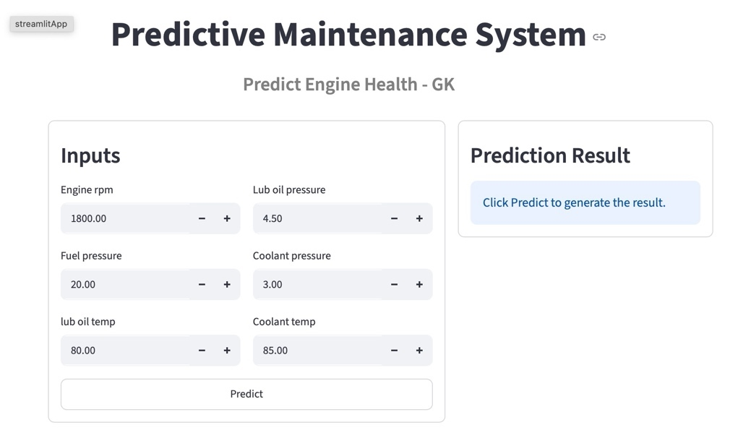

Figure 14.2.2 — Prediction Output (Normal Operating Condition)
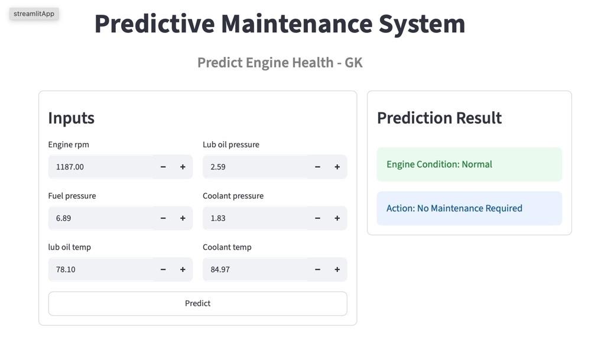

Figure 14.2.3 — Prediction Output (Maintenance Required Condition)
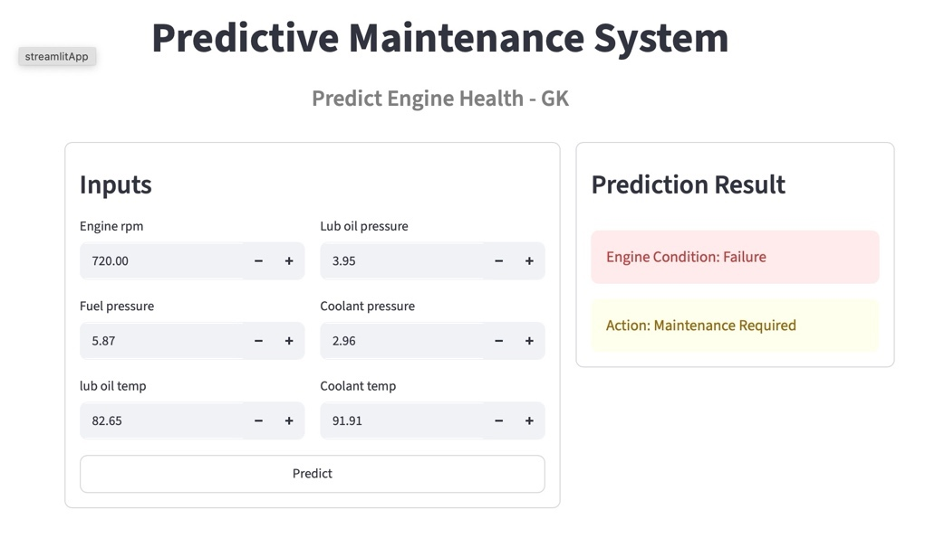

14.3 Hugging Face Hosted Application Output

Figure 14.3.1 — Hugging Face Hosted Application Interface
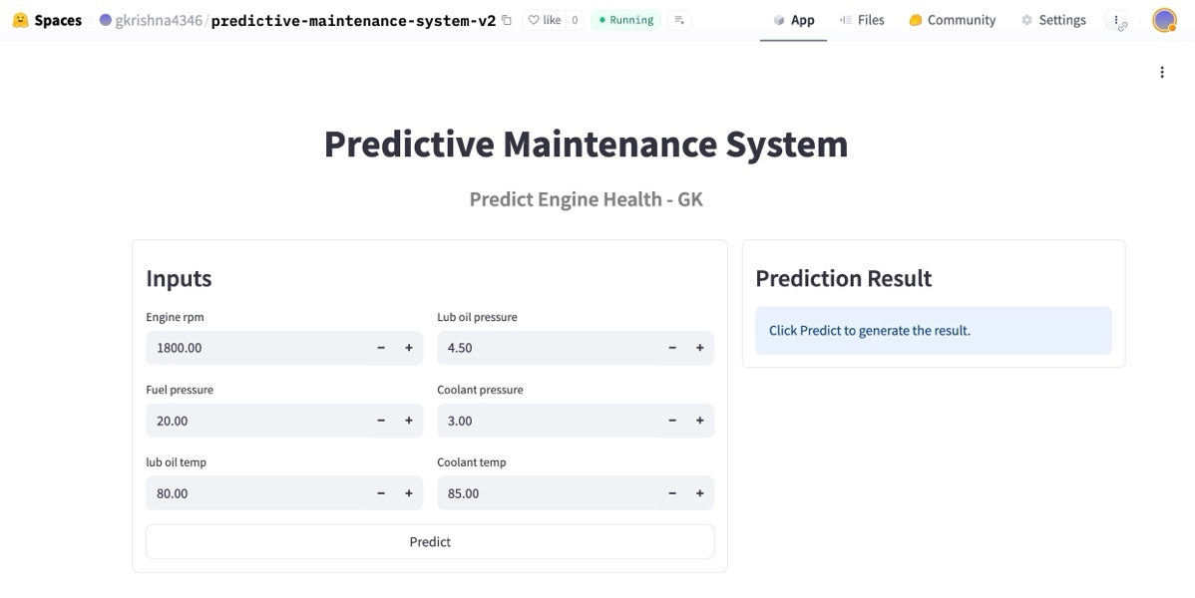

Figure 14.3.2 — Prediction Output (Normal Operating Condition)
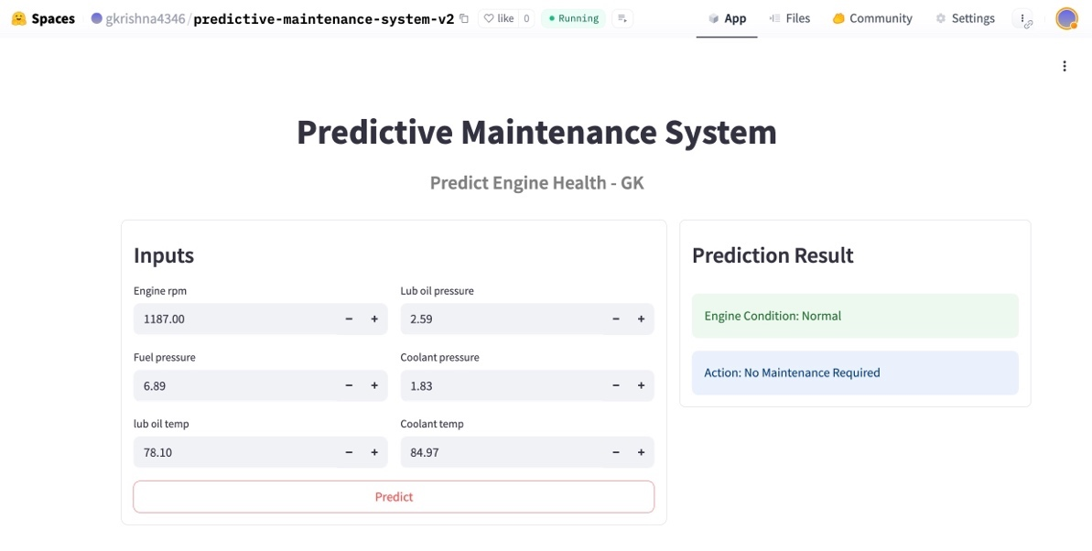

Figure 14.3.3 — Prediction Output (Maintenance Required Condition)
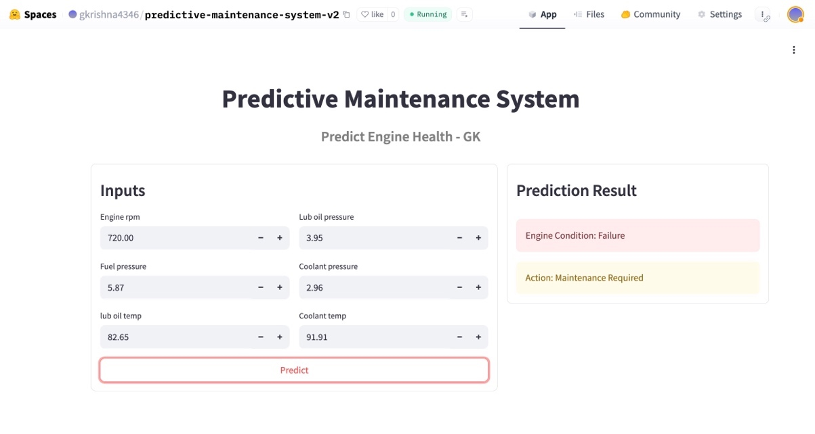

14.4 Hugging Face Model Repository

Link - https://huggingface.co/gkrishna4346/predictive-maintenance-adaboost

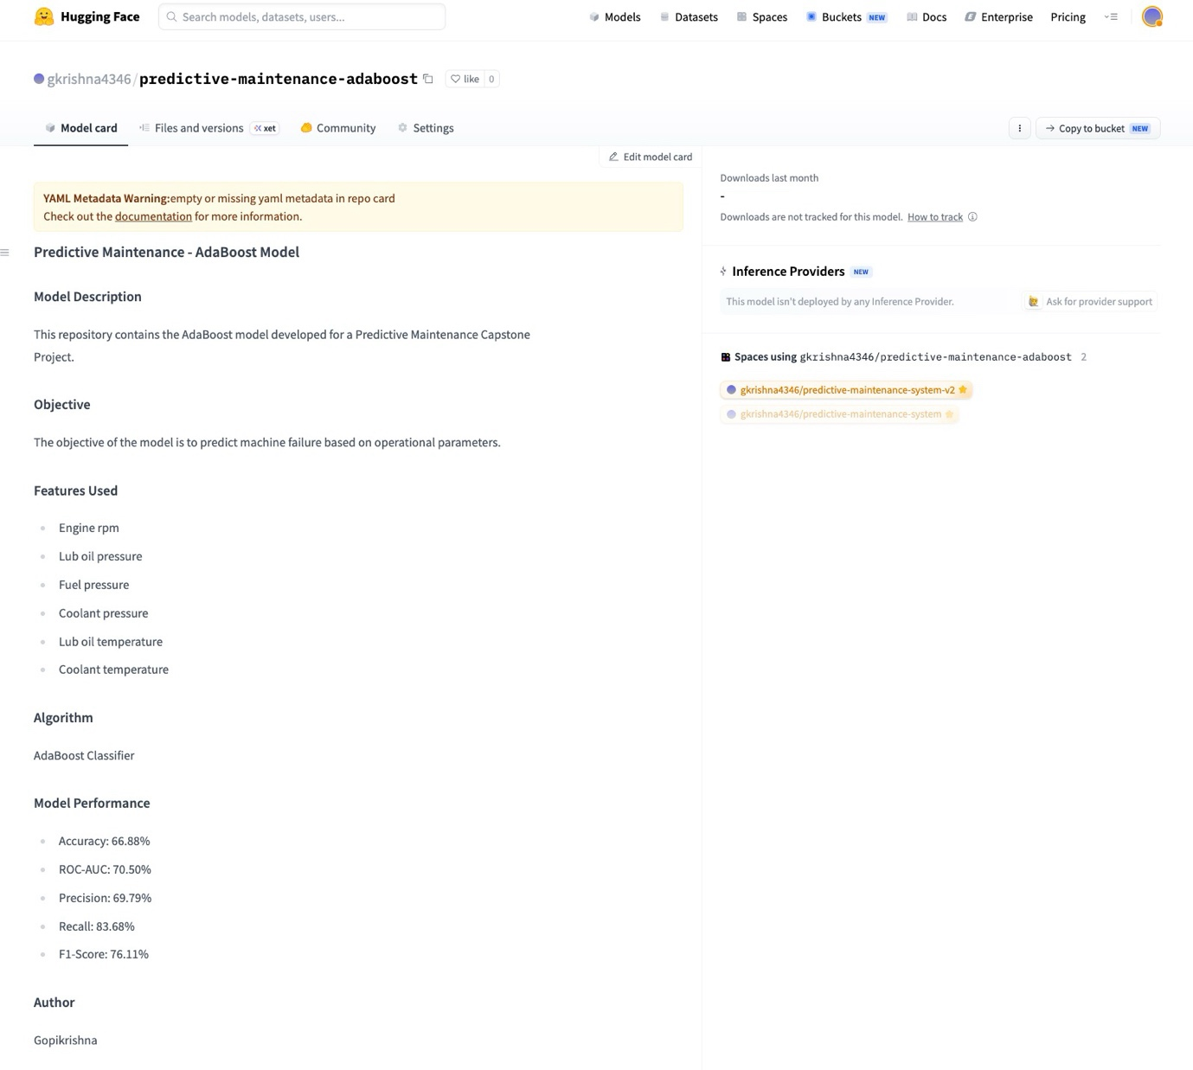

Hugging Face was used to host the application and store the trained model artifact for deployment and inference.

14.5 Deployment Artifacts and Access Links

The following deployment artifacts and hosted application links are provided to enable verification, accessibility, and reproducibility of the deployed predictive maintenance solution.

Deployment Component | URL
GitHub Repository | https://github.com/gkrishna4346/predictive-maintenance-capstone
Hugging Face Space | https://huggingface.co/spaces/gkrishna4346/predictive-maintenance-system-v2
Streamlit Application | https://gkrishna4346-predictive-maintenance-capsto-deploymentapp-vbhras.streamlit.app

15. Actionable Insights and Recommendations

The predictive maintenance solution demonstrated that machine learning can identify engine maintenance requirements using operational sensor data and support proactive maintenance decision-making. Based on exploratory analysis, model evaluation, hyperparameter tuning, and deployment outcomes, the following business insights and recommendations were derived.

15.1 Key Business Insights

Insight 1 — Engine RPM emerged as the strongest predictor
Finding | Engine RPM showed the strongest association with engine condition among all variables.
Interpretation | Variations in RPM can act as an early operational signal before engine degradation becomes critical.
Recommendation | Implement continuous RPM monitoring to support proactive maintenance planning.

Insight 2 — Engine condition is influenced by combined sensor behaviour
Finding | Engine condition was influenced by multiple variables, and ensemble models improved performance by capturing their combined effects.
Interpretation | Single-threshold monitoring may overlook complex interactions between operating conditions.
Recommendation | Adopt integrated monitoring across RPM, pressure, and temperature measurements.

Insight 3 — Ensemble learning improved predictive performance
Finding | Comparative evaluation demonstrated superior performance from ensemble models over standalone approaches.
Interpretation | Combining multiple learners improved prediction reliability and robustness.
Recommendation | Use ensemble-based predictive maintenance models for operational decision support.

Insight 4 — AdaBoost achieved the most balanced model performance
Finding | AdaBoost delivered the best balance across Accuracy, Precision, ROC-AUC, and overall stability.
Interpretation | The model provides dependable performance while reducing unnecessary maintenance actions.
Recommendation | Deploy AdaBoost as the baseline production model and periodically retrain with new operational data.

15.2 Expected Business Benefits

- Recommendation 1 — Adopt condition-based maintenance
Move from fixed maintenance intervals toward sensor-driven maintenance planning.
  - Expected Benefit:
- Reduced unexpected breakdowns
- Improved asset availability
- Lower maintenance overhead

- Recommendation 2 — Introduce real-time monitoring dashboards
Integrate the deployed prediction system with operational dashboards to continuously monitor engine condition.
  - Expected Benefit:
- Faster operational response
- Improved maintenance visibility

- Recommendation 3 — Expand feature collection
Future versions may include:
- Vibration data
- Runtime hours
- Load conditions
- Environmental variables
  - Expected Benefit:
- Higher predictive performance
- Improved model generalization

- Recommendation 4 — Establish retraining governance
Define a retraining schedule using newly collected operational data.
  - Expected Benefit:
- Sustained prediction reliability
- Better adaptation to operational changes

15.3 Expected Business Value

Area | Expected Outcome
Maintenance Cost | Reduction through targeted servicing
Equipment Reliability | Improved operational continuity
Downtime | Lower unplanned interruptions
Decision Making | Faster data-driven actions
Scalability | Reusable deployment architecture

15.4 Future Enhancements
- Enable automated retraining through GitHub Actions workflows
- Add model monitoring and prediction logging
- Introduce alert notifications for high-risk predictions
- Expand deployment to production-grade cloud environments

Topic | Checklist | Status
1. Report Structure | Cover Page included | Yes
 | Table of Contents included | Yes
 | Page numbers present | Yes
 | Section numbering is sequential | Yes
 | Headings follow consistent formatting | Yes
 | Report does not exceed page limit | Yes
 | Figures and tables are numbered | Yes
 | Figure/Table captions provided | Yes
2. Business Understanding | Business problem clearly defined | Yes
 | Business impact explained | Yes
 | Project objective clearly stated | Yes
 | Success criteria explained | Yes
 | Predictive maintenance use case justified | Yes
 | Business value communicated | Yes
3. Data Understanding | Dataset description provided | Yes
 | Data source identified | Yes
 | Target variable explained | Yes
 | Feature descriptions included | Yes
 | Dataset size documented | Yes
 | Assumptions disclosed | Yes
 | Data limitations discussed | Yes
4. Exploratory Data Analysis (EDA) | Dataset overview included | Yes
 | Target distribution visualized | Yes
 | Feature distributions analyzed | Yes
 | Correlation analysis performed | Yes
 | Feature vs Target analysis included | Yes
 | EDA observations documented | Yes
 | EDA summary table included | Yes
5. Data Preparation | Missing value analysis performed | Yes
 | Duplicate analysis performed | Yes
 | Outlier assessment discussed | Yes
 | Feature selection justified | Yes
 | Train-test split documented | Yes
 | Data readiness summary provided | Yes
6. Model Building | Multiple models evaluated | Yes
 | Model rationale explained | Yes
 | Model building process documented | Yes
 | Algorithms clearly identified | Yes
 | Hyperparameter tuning included | Yes
 | Best parameters reported | Yes
 | Experimentation process explained | Yes
7. Model Evaluation | Accuracy reported | Yes
 | Precision reported | Yes
 | Recall reported | Yes
 | F1-Score reported | Yes
 | ROC-AUC reported | Yes
 | Comparison table included | Yes
 | Best model selection justified | Yes
 | Metrics interpreted correctly | Yes

Topic | Checklist | Status
8. Hyperparameter Tuning | Hyperparameter tuning objective defined | Yes
 | Tuned parameters documented | Yes
 | Parameter search method explained | Yes
 | Candidate parameter combinations evaluated | Yes
 | Performance comparison included | Yes
 | Best parameter set selected | Yes
 | Final tuned model justified | Yes
9. Model Deployment | Deployment architecture documented | Yes
 | Dockerfile configuration included | Yes
 | Model loaded from Hugging Face Model Hub | Yes
 | Input collection and DataFrame creation explained | Yes
 | Deployment dependencies documented | Yes
 | Hosting workflow demonstrated | Yes
 | Deployment output validated | Yes
10. Automated GitHub Actions Workflow | pipeline.yml file created | Yes
 | Workflow trigger conditions defined | Yes
 | YAML execution steps documented | Yes
 | Repository integration completed | Yes
 | End-to-end automation explained | Yes
 | Workflow execution validated | Yes
 | Deployment synchronization demonstrated | Yes
11. Output Evaluation | GitHub repository output included | Yes
 | Repository structure demonstrated | Yes
 | Workflow execution captured | Yes
 | Hugging Face deployment validated | Yes
 | Streamlit application output included | Yes
 | Positive prediction scenario shown | Yes
 | Negative prediction scenario shown | Yes
12. Actionable Insights and Recommendations | Business insights derived from results | Yes
 | Model impact explained | Yes
 | Predictive maintenance recommendations provided | Yes
 | Operational benefits discussed | Yes
 | Future enhancement opportunities identified | Yes
 | Business value summarized | Yes

